**Report on Generative Model Training with Tensorflow**

Jiayu Wu | 905054229

1. **GAN**

**Training Outcome:** (batch size = 100 for each step) 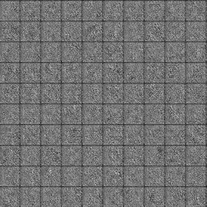 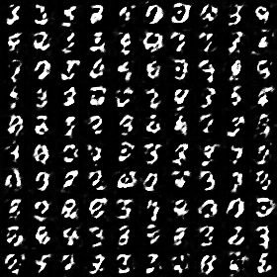 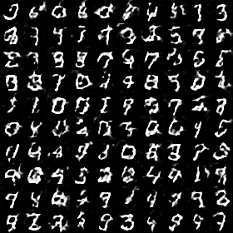 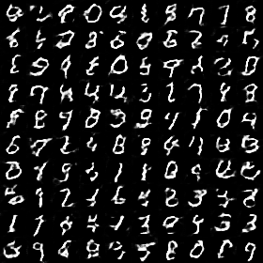 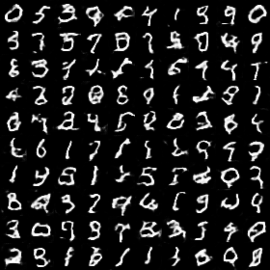

Step 0 Step 200 Step 400 Step 600 Step 800

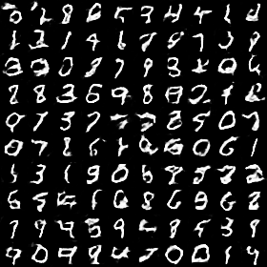 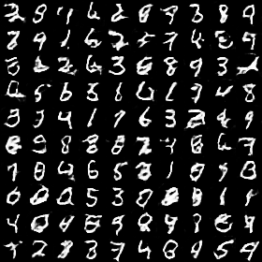  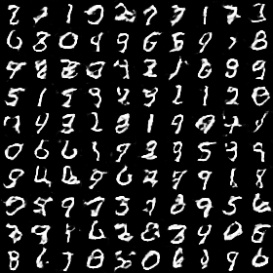 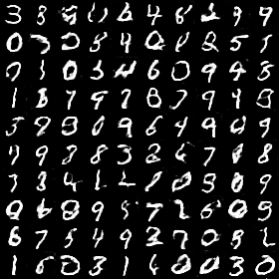

Step 1000 Step 1200 Step 1700 Step 2200 Step 3000

The training yields generally satisfying result in less than five epoch of training. The model converges and stabilizes very quick and generates images similar to the original examples. However, not all of the generated images resembles a number, and the model fail to improve further.

**Training Process:**

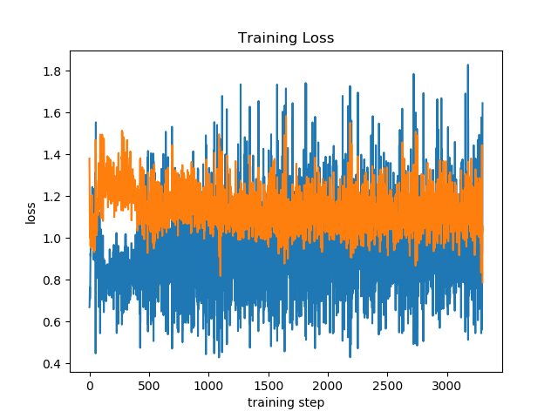

generator loss

discriminator loss

In this task, generator is relatively harder to train than the discriminator. There are two methods to achieve faster convergence: 1) update G network multiple times in each training phase; 2) use more complex network for G network. In this training process, G network has 1 fully-connected and 3 convolutional layer and is updated twice in each training step.

Another notable detail is that the last layer of G network should not use batch normalization, which rescale and diminish the feature.

1. **VAE**

**Training outcome:** (batch size = 1000 for each step, first 100 are presented below)

Original Reconstruction Sampling 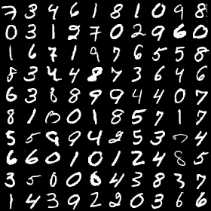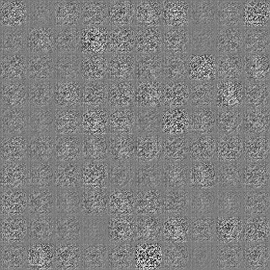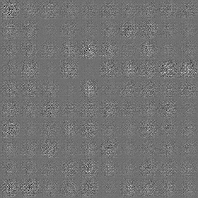Step 0 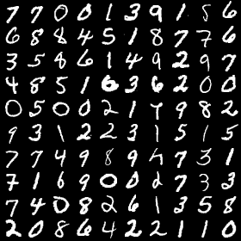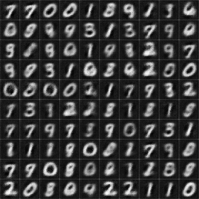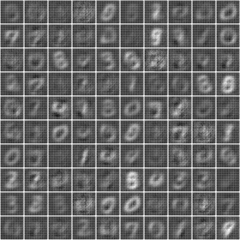Step 200

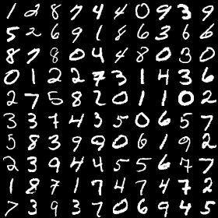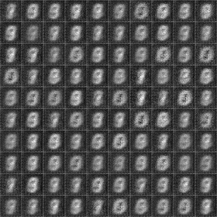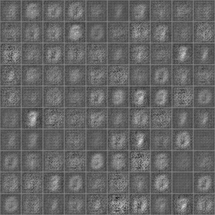Step 50 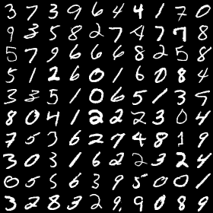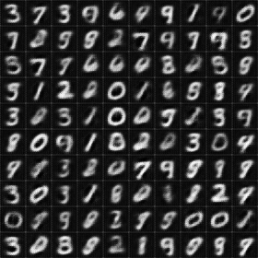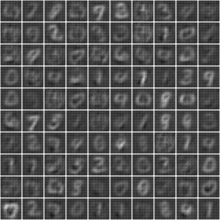Step 500

The reconstructed image gets increasingly closer to the original examples within 500000 training examples. The generated numbers are mostly recognizable and resembles original examples, however the image is a lot more obscure.

Training Process

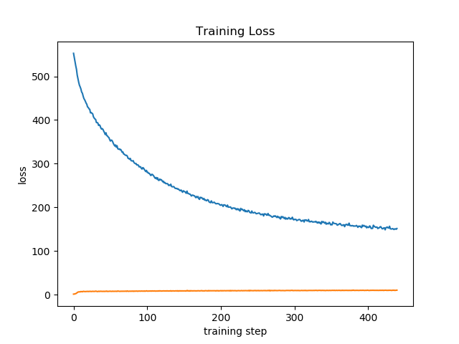

Originally, the total loss decreases from over 500 to around 180 during the whole training process, while the KL divergence loss only decrease from 9 to 6 as in the plot above on the left. It can be observed that the cross-entropy loss dominates the total loss.

Because the training result seem to be blurred, I have tried several modifications like scaling the pixels, rescaling the KL divergence loss, etc. However, the result doesn’t improve much due to time constraints. The next step may be re-design the network or the loss term.